Nicolás Christie  nicolas.christie@gmail.com | (+49) 176 6768 9097  Salzmesserstr. 77, 81829 – Munich, Germany  LinkedIn Xing GitHub | 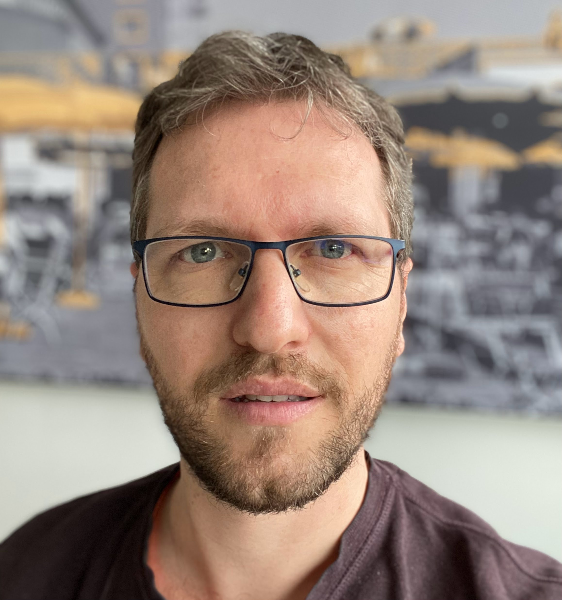
Work Experience
11.2020 – present Brainlab Munich, Germany
Senior Business Applications Developer / Power Platform & SharePoint Administrator
- Leading the design and development of advanced enterprise applications for a global organization of 3,000+ employees. Building integrations across SAP, SharePoint, and Salesforce through an ESB (C#), and implementing scalable workflow solutions using Azure services and the Power Platform (PowerApps, Power Automate). Responsible for Power Platform and SharePoint administration, governance, and best-practice adoption. Using LLMs and ML to process data and extract metrics from databases.
- C# .NET, HTML, React, Azure, Python, Ollama, Power Platform, SharePoint and SQL development.
About the company: Brainlab is a healthcare equipment developer, and has been innovating for over 35 years in the areas of surgery and radiation therapy, developing hardware and software technology to help healthcare providers, physicians and their patients fight cancer and other conditions of the brain and body.
05.2017 – 10.2020 EURO-LOG A.G. Hallbergmoos (Munich), Germany
Senior Software Developer
- Engineering advanced Transport and Supply Chain Management logistics administration websites for diverse, multi-targeted industries. This involved optimizing performance to efficiently handle and process high-volume data requests, ensuring robust and scalable solutions for complex logistical operations.
- ASP.NET C#, HTML, JavaScript and SQL development.
About the company: Euro-Log is a logistics service provider for Transport-, Container- and Supply Chain- Management Systems, shipment tracking and administration for automotive, e-commerce, retail and other industries.
05.2011 – 04.2017 TecnoCientífica S.A. Ciudad Autónoma de Buenos Aires, Argentina
Project Architect (R&D Department)
- Innovating and implementing comprehensive software, firmware, and hardware solutions to seamlessly integrate management software with hardware devices, both in laboratory settings and embedded within processing plants. Successfully migrated, re-designed, and unified three distinct product/device families into a single cohesive Software (WinForms .Net C#) + Firmware (C++) solution for multiple hardware devices (PIC18 µProcessors), incorporating a versatile RS232+CAN+I2C communication protocol to ensure robust connectivity and performance in hostile working environments.
- Firmware, hardware and software design/development.
About the company: TecnoCientífica is a service, technical assistance and consulting provider, manufacturer of quality measure and control devices and multi-device solutions for food processing industries including laboratory and real-time multi-point in-plant embedded solutions.
06.2009 – 10.2010 Sistelcom S.R.L. Ciudad Autónoma de Buenos Aires, Argentina
Hardware & Software Developer
- Engineered remote electronic lock trackers, satellite-connected temperature control systems for refrigerated products, GPRS and satellite status reporting solutions and RFID driver login systems. All projects requiring a high focus on security standards.
- Firmware, hardware and software development.
About the company: Sistelcom is a transport security service provider, research, development, integration and commercialization of electronic security solutions applied to logistics, such as freight temperature tracking and electronic container locks.
Education
2019 – 2020 Udacity.com
Self-Driving Car Engineer Nanodegree Program.
2003 – 2009 Instituto Tecnológico de Buenos Aires
Electronics Engineering Diploma
Specialization: Telecommunications
Languages Spanish (native), German (C2/fluent) and English (C2/fluent).
Skills Summary
Power Platform
Canvas Apps
Power Automate
Power BI
Azure
Azure DevOps
C#
SharePoint
ASP.Net/.Net
SQL
HTML
CSS
JavaScript
Node.js
React
Python
MongoDB
C/C++
Matlab
Software: Power Platform Canvas Apps, Power Automate Power BI, Azure, Azure DevOps, C#, Microsoft SharePoint, ASP.NET/.NET, SQL, HTML, CSS, JavaScript, Node.js, React, Python, MongoDB, C/C++, Matlab.
Hardware: PIC (Microchip) microcontrollers, LPC (NXP/Philips) microcontroller families LPC111x, LPC17xx, LPC23xx, ZigBee controllers (XBee), GPS, GPRS, RFID, CPLD, FPGA, CAN, I2C, Stepper/Servo/Linear motors, temperature sensors.
PIC (Microchip)
LPC (NXP/Philips)
ZigBee
XBee
GPS
GPRS
RFID
CPLD
FPGA
CAN
I2C
Servo/Linear/Stepper Motors
Temperature sensors
Algorithms: SLAM, Computer Vision, Convolutional Neural Networks, Sensor Fusion, U/EKF, PID, DSP, LLMs, L
SLAM
Computer Vision
Convolutional Neural Networks
Sensor Fusion
U/EKF
DSP
PID
LLMs
ML
Other
Projects
- (2009) Thesis project, implementation of automated lighting control system and presence detection.
- (2009) First place in the 2008 edition of the ITBA R&D contest for our work in “Pre-processing of images for matrix code (QR codes) decoding in embedded systems”.
- (2008) Mention of honor in the 2007 edition of the ITBA R&D contest for our work in “An Image Restoration Method for Natural Scene Images Distorted by Camera Shake Blurring”.
- (2008) Research and implementation of a speed control system using magnetic brake adjustment.

